## Merchant: MavenAGI

Demo date:   
Scoping start date: n/a

MSA Signature Date: Jun 27, 2025  
Onboarding Kick Off Date: Jun 30, 2025

[If Exists] Opt Out Date: none  
Go Live Date: Nov 14, 2024

GTM POC: Jarrett  
Implementation POC: Jeff

ERP: QBO

Tax Integration: No Tax

### 

### Key people at Merchant

### **Accountant:** Tracy Wayne

### **Lauren Murphy** (Head of Operations, oversees Finance/Legal/People)

### **Customer service rep who is really involved:** Jillian Smerechniak (Finance Manager)

### **Accounts Receivable POC:** Jillian Smerechniak

### **Billing POC:** Jillian Smerechniak

### **RevOps / HubSpot POC:** Mitch Morrison

### 

| Notes Sections [Ops International Team to Ignore] *(AE/ Implementation to fill)*  **Info on how merchant bills:**   * Currently contract data sits in HubSpot with PDFs attached. * All invoices are created manually in QuickBooks based on contract data. * Revenue recognition is done manually in Excel. * Manual dunning and collections—tracked in spreadsheets. * Some customers are billed fixed platform fees, others via prepaid usage credits; overage triggers a new invoice. * Invoices are long and often require customized descriptions. Tracy manually edits these in QuickBooks. * Tabs will automate contract ingestion, invoice creation, usage billing, rev rec, and dunning.   **Is there any important merchant relationship information?**   1. **What is the merchant temperament?** Highly collaborative, fast-moving, and organized. Post-Series B with an urgency to build infrastructure for scale. 2. **Key POC / Decision Makers:** Lauren Murphy (ultimate decision-maker), Jillian (day-to-day finance lead), Mitch (RevOps integration lead) 3. **Key Tabs features they care about:**  * PDF contract ingestion + automated billing * Usage + prepayment + overage handling * Revenue recognition + cash forecasting * Dunning automation + Slack reminders * HubSpot sync (writeback invoice/payment status) * Invoice customization (headers, contacts, descriptions) * Role-based user permissions and audit-ready exports   SFP is the partner, Light Labs is their client.  3) What are the Tabs features that the key POC cares about? |
| --- |

### 

### Company summary *(AE to fill)*

Maven AGI builds agentic AI solutions for enterprise support and success teams. They are a Series B stage company, rapidly scaling both customer count and billing complexity. They view Tabs as a strategic system of record for AR, billing, collections, and reporting.

Goals (North star)  
*(AE/ Implementation to fill)*

What is the merchant's goal? What pain are we solving? Why are they buying Tabs?

Maven AGI wants to:

* Eliminate manual invoicing and spreadsheet-based revenue workflows
* Automate collections to reduce late payments
* Support usage-based billing with prepayment and overage logic
* Improve visibility into ARR, aging, rev rec, and commissions
* Enable tight sync between QuickBooks and HubSpot

Is there an opt out clause? If so, what is the merchant looking for so they do not exercise it?

### Billing model *(AE/ Implementation to fill)*

* Mix of prepaid usage (credits) and fixed platform fees.
* Usage tracked outside current system (in Google Sheets/CSVs); Tabs will import via API or CSV.
* Overages trigger standalone invoices.
* Contract terms differ customer to customer (monthly, quarterly, annual).
* Invoice descriptions need to be contract-specific and editable.

### Contract Processing Steps *(Implementation/Success to fill)*

* **General**
  + Most contracts will be order forms
  + IF there is any mention of an “overage” we will need to turn usage AI -> these will be threshold usage AI models to track the prepaid amounts
* **Item Name + Integration Item:** use the item name and integration item in the mapping below
  + If the item name doesn’t fit, please use a simple, clean name derived from the contract. Can use best judgement

| **Item Name in Contract** | **Correct Item Name** | **Integration Item** |
| --- | --- | --- |
| 10% 1x- Maven Partnership Discount (End of August Promo) | Discount | Discount |
| Annual Platform Fee | Annual Platform Fee | Annual Platform Fee |
| Maven AGI Product Licenses | Maven AGI Product Licenses | Maven AGI Product Licenses |
| Resolution Volume 17000 @ $ 2.00/resolution | Resolutions | Resolutions |
| Additional Resolutions | Resolutions | Resolutions |
| Maven Integrations | Maven AGI Product Licenses | Maven AGI Product Licenses |
| Ticket Volume: 2083/mo | Resolutions | Resolutions |
| Maven AGI Product Licenses: | Maven AGI Product Licenses | Maven AGI Product Licenses |
| Multi Year Discount | Discount | Discount |
| Maven Partnership Marketing Discount | Discount | Discount |
| Resolution Volume: 25,200 @ $3.75/resolution | Resolutions | Resolutions |
| Resolutions | Resolutions | Resolutions |
| Discount | Discount | Discount |
| Start-Up Edition | Annual Platform Fee | Annual Platform Fee |
| Interaction Volume | Interactions | Interactions |

* **Quantity:** 
  + Use quantity listed; default to 1.
  + For Resolution Volume, make sure to use the quantity purchased
    - “175,000 @ $0.76/resolution” = 175,000 quantity
* **Total Price**
  + Use the listed total amount divided to match the listed billing period
    - Most total prices are listed annually and common billing periods are quarterly and upfront (divide annual total by 4 for quarterly)
    - Sometimes the specific payment cadence is listed under the BT table in the payment schedule (see below)



* + Process all $0 BTs
* **Discounts:**
  + Need to use in-line discounting and spread it evenly amongst the relevant products
  + Use the % if it is listed for each product
    - If not available, calculate the % by dividing the discount $ amount by the total $ amount and use that % on the individual products
  + Do not create separate negative BTs UNLESS
    - “Partnership Credit” should be treated as a separate negative BT discount.
* **Service Start Date:** use the effective date
* **Billing Start Date:** same as Service Start Date unless the Payment Schedule (above screenshot) specifies an explicit invoice date.
* **Months of Service:** use the “Initial Term” section
* **Frequency:** use “Billing Period” section unless the Payment Schedule specifies otherwise
* **Net Terms:** use “billing method” section; default to net 0
* **Overages:** ignore any overage language that states "billed at agreed on per ticket pricing" since no fixed rate is provided.
* **Usage AI:**

1. Most common situation: “*Overages will billed at agreed on per ticket pricing annually” [EXAMPLE](https://garage.tabsplatform.com/prod/contracts/9787ed4d-dd04-4ff3-a2bf-dae6cbee0ba7/usage)
   1. Create a usage BT annually in arrears for the resolution unit price that they were purchased at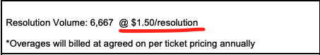
      1. Item name: “Resolutions (Usage)”
      2. Integration item + event is resolutions
   2. Set up usage AI as a threshold that charges overages

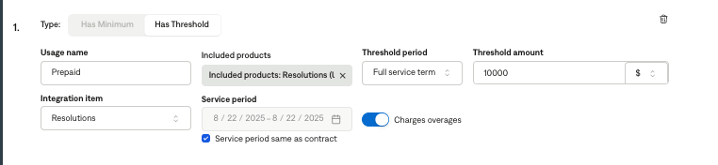

* + - * Item name: prepaid
      * Full service term threshold period
      * Integration item is resolutions
      * Call it overage
      * Threshold amount is the amount that was prepaid for

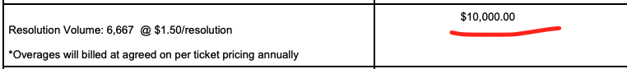

* + - * If you see this clause, **ignore**. Still use the regular resolution rate as listed about for the usage BT

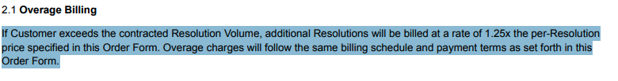

1. Variations of a tiered unit price and/or multiple years with different prepaid amounts
   1. [Example](https://garage.tabsplatform.com/prod/contracts/6c7b9684-38ab-4b06-bf73-6b78c8302dfd/usage)
   2. Context:
      1. 3 different prepaid amounts for 3 different years.
      2. Resolution usage BT is tiered and goes for all 3 years
      3. First year, the threshold is slightly higher than the prepaid amount
         1. “For Year 1, Resolutions # 135,001 to 168,750 will be provided at no additional charge. Overages will be billed only when the Customer exceeds 168,750 Resolutions, at a rate of $0.86 per Resolution for each Resolution above that threshold.”
   3. Create a tiered unit BT with the below and make it annually in arrears for the entire term
      1. 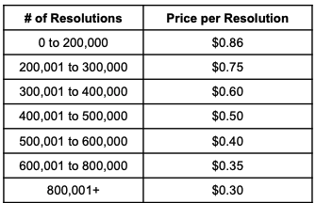
   4. Create 3 years of usage AI models for each year and select that tiered usage BT (should be called “Resolutions (Usage)”
      1. Will have to unselect “service period same as contract” and type in the exact date range for each year (make sure they don’t overlap). Screenshot below
      2. The first year, need to multiply the $0.86 rate by the top of this range “For Year 1, Resolutions # 135,001 to ***168,750*** will be provided at no additional charge” and that will be the threshold amount

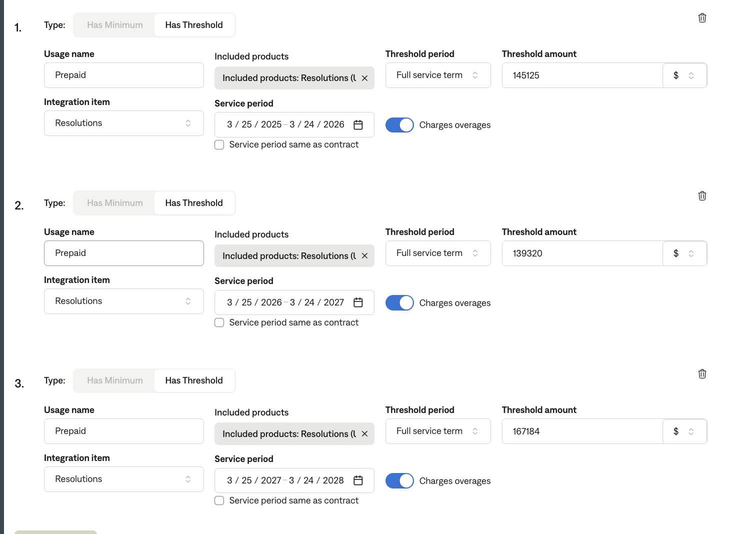

* + There will be a few different variations of this model. This is just an example
* **Sales Tax:** 
  + Ignore / do not process if item says “(only where applicable)” next to it
  + Make sure garage total matches the total payment due number in the contract

**Examples:**

* **Digital.ai** → 15-month term, Quarterly billing, first invoice includes Platform Fee + partial resolution allocation. ([LINK](https://garage.tabsplatform.com/prod/contracts/2f3eb9a8-d919-4d1c-9ae0-dce43e9182c3/preview))
* **UltraCamp** → Quarterly billing, separate BTs for Platform Fee and Resolution-based charges. ([LINK](https://garage.tabsplatform.com/prod/contracts/3d8c64a5-433e-4ddc-af77-5f2315fae1a4/preview))

### Events Processing (if necessary) *(Implementation/Success to fill)*

* Any important information on events billing

Integration Items Processing (if necessary)  
*(Implementation/Success to fill)*

* What are the instructions for assigning integration items?
* Example: All Statsig integrations items should be labeled as “Sales”
* Example: All “Pinata” integration items should be labeled as “Software Subscription Bundle” unless otherwise noted by Merchant

Post Processing Communications (if necessary)  
*(Implementation/Success to fill)*

* Does the Ops Team need to notify anyone on the team re: completion of processing batches in Implementation or Active phase?
* Who needs to be notified and when?
  + Example:
    - Who: Customer Success [Azmat Aziz] needs to be notified
    - Where: Messari internal merchant channel
    - When: contracts are processed [Merchant Phase: Active]

### Customer Information *(Implementation/Success to fill)*

* Any important information on specifics customers of this merchant
  + Special memo’s certain invoices require
  + Invoice changes due to merchant/customer relationship

### Feature Requests *(AE/Implementation/Success to fill)*

* FR 1
  + What is it
  + Why it's important
  + Urgency

### Rewatch Calls *(AE/Implementation/Success to fill)*

* Rewatch by dates